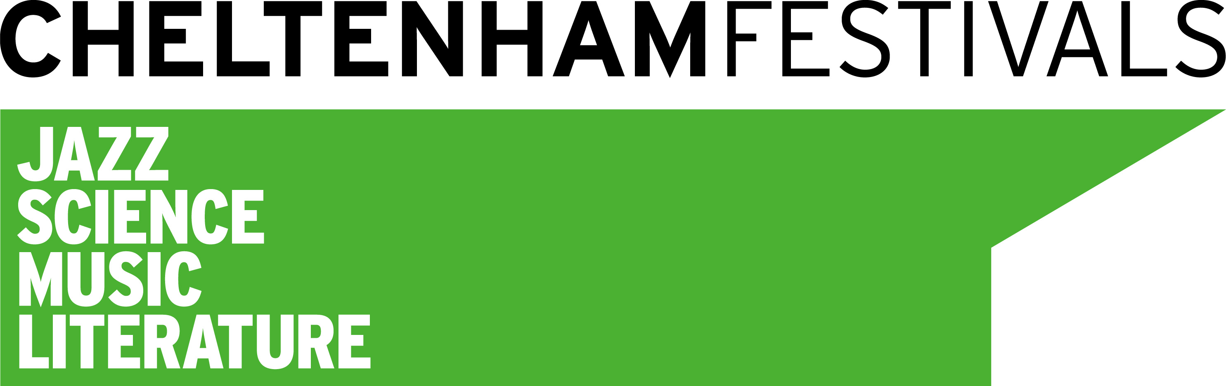
Science Festival Director

Salary: c. £45-50k depending on experience
+ 5% pension contribution

The Cheltenham Science Festival is evolving and in order to achieve our ambition we are seeking an energetic, inventive leader with new perspectives who is itching to lead the development and build relations nationally and internationally.

You are probably as interested in what motivates people, as you are fascinated by how science underpins our past, present and future. You are excited by new ways of igniting interest, making a sustainable impact and inspiring people; young, older and everything in between.

Cheltenham Festivals develops and shows four annual festivals in Jazz, Science, Music and Literature as well as year round educational projects.

For a downloadable candidate brief please refer to http://www.cheltenhamfestivals.com/jobs

Closing date for applications: 12 noon Friday 17th April 2015

First Interviews to be held in Cheltenham on : Wednesday 29th April 2015
Charity No: 251765

.

