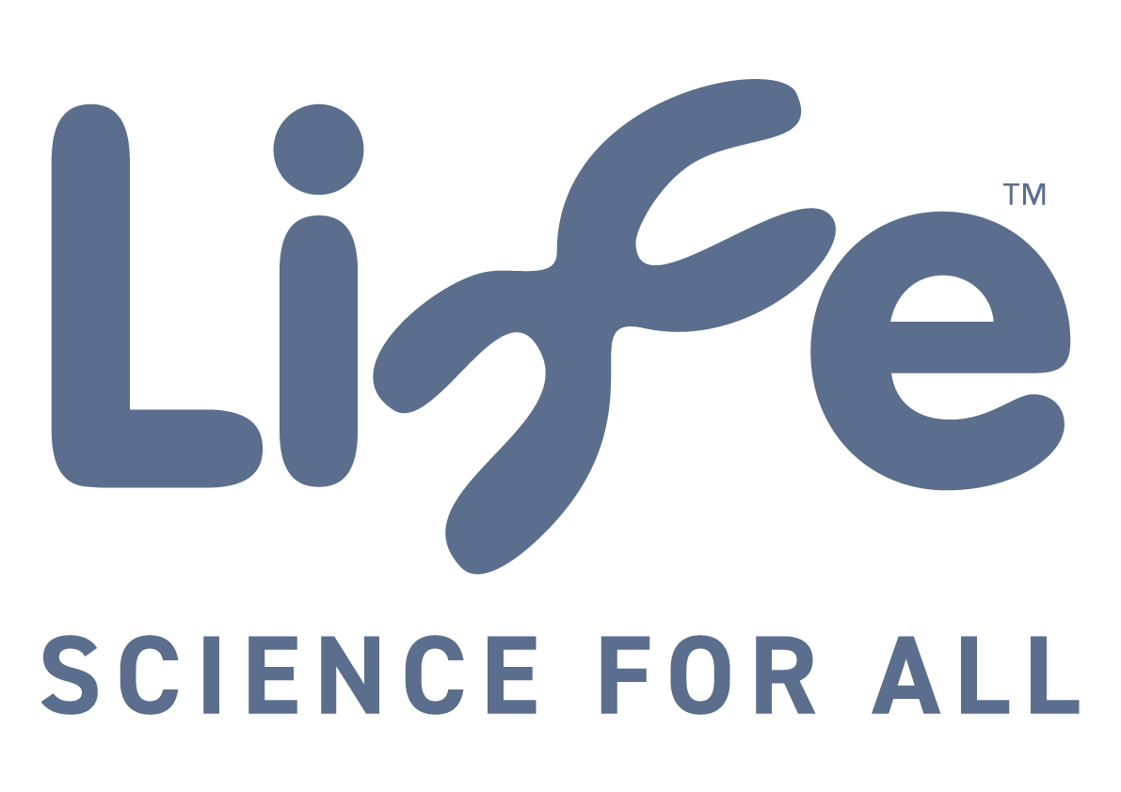

Life’s purpose is to inspire everyone in North East England to explore and enjoy science and to discover its relevance to their own lives.
We are one team and everything we do is rooted in the following values:
Welcoming: our team, our customers and our communities are diverse and we celebrate that! We want everyone to feel comfortable, respected and valued.
Exceptional: our customers and staff deserve the best and we go over-and-above to exceed their expectations.
Honest: we are trustworthy, unbiased and behave fairly, ethically and responsibly at all times.
Curious: we encourage everyone to question everything and explore science and technology through hands-on experiences and individual discovery.
Entrepreneurial: we’re not scared to push boundaries and try bold, unusual and edgy ways to achieve our ambitions.
Collaborative: we will continue to partner those who share our passion and values.​​​​​​​

JOB TITLE: MAKER

RELATIONSHIPS:

- Responsible to:
Lead Maker

- Important Internal Relationships:
Head of Public Engagement
Science Engagement Director
Science Engagement, Operations, Technical and Marketing teams.

- Important External Relationships:
- All visitors to the Centre for Life, with particular emphasis on families of all ages.
- The maker, engineering and digital community including Maker Faires, Hackerspaces and similar organisations.
- The national and international science centre community specifically teams working with making and tinkering activities.
- Contractors and suppliers.
- Funders.

MAIN PURPOSE OF THE JOB:

- To work as part of a team to develop and deliver the Making Studios programme for a range of audiences to make, tinker and invent, developing skills and positive attitudes around science, technology, engineering and maths (STEM).
- To support and help train the delivery team to deliver a high-quality learning experience in the Making Studios for our audiences.
- Support the operation of the Making Studios, creating a safe, welcoming and clean environment.
- Share making skills and embed our making and tinkering philosophy across Life through advocacy and staff training.
- To help support collaborations and coordinate visiting makers and organisations to deliver maker events in the Centre to deepen engagement with making and tinkering.
- To maintain consistency of offer which will require working weekends and school holidays where needed.

Prepared by Agreed by
Signature ---------------------- Signature ---------------------

Date ---------------------- Date ---------------------

JOB DESCRIPTION: Maker

- Work as part of a team to develop, prototype and prepare a programme of making and tinkering activities, workshops and resources for a wide range of audiences including families, school students and adults, that fire up imaginations and develop STEM skills, aspirations and attitudes.
- Deliver and facilitate imaginative, relevant and accessible making activities to visitors, schools and community groups in the Making Studios, online and through outreach.
- Work with staff and project teams to innovate and experiment with new content and programme styles, to ensure a reputation for trialling bold, novel and unique content and programmes.
- Support and help train team members to facilitate and deliver high quality, engaging and inspiring making activities that embrace our making and tinkering philosophy.
- Support the Making Studios operation, ensuring a clean, safe and welcoming environment for our visitors.
- Manage, procure, use and maintain creative, sustainable and accessible materials, tools and resources for these activities.
- Co-ordinate with other departments regarding Making Studios and the making and tinkering programme to ensure it is a collaborative space and it runs smoothly.
- Help support collaborations and partnerships with external organisations to ensure events in the making studio run smoothly.
- Help to evaluate programmes to help embed a culture of reflective practise.
- Work within and implement the Centre’s Health and Safety policy and standards.
- Any other reasonable duties required.
JOB TITLE: Maker

PERSONAL CHARACTERISTICS

- Creative and imaginative with a ‘maker’ mindset
- Skilled in crafting prototypes from different materials
- Uses their own initiative
- A motivated team player
- Detail oriented and methodical
- Confident
- A positive, encouraging facilitator
- A great communicator
- Analytical

EXPERIENCE

ESSENTIAL
- Communicating successfully to a wide range of audiences
- Work with children supervising craft or skills-based activities
- Experience with craft, design and technology tools
- Experience of developing and delivering making and tinkering activities to a variety of audiences
- Working in a busy, fast-paced environment
- Experience of working with laser cutters, 3D printers and similar

DESIRABLE
- Experience of developing and delivering training
- Experience in a science communication or education setting
- Facilitating activities whilst working remotely
- Work with maker spaces and organisations, ideally in the North East and/or UK
- Copy writing for a variety of audiences
- Equipment maintenance

SKILLS, KNOWLEDGE AND QUALITICATIONS

ESSENTIAL
- Good written and oral communication skills
- Good presentation and facilitation skills
- Good organisational skills with attention to detail
- A range of physical and digital making skills
- The ability to work within different software packages
- The ability to research ideas and use materials in imaginative ways

DESIRABLE
- Familiarity with working with digital tech such as Arduino, Raspberry Pi or similar in a maker context
- Experience of CAD software
- The ability to code and support others to learn coding
- Teaching qualification
- A degree in a STEM or creative subject, or equivalent qualification
- Driving licence

