Dear *|Title|* *|Last Name |*,

I am pleased to send you the position of Ecsite, the European network of science centres and museums, on the future Framework Programme for Research and Innovation (FP9).

We believe that for a democratic and sustainable Europe, FP9 should actively involve citizens in the science and innovation process. This is the role of professional science mediators working in science engagement organisations such as science museums/centres.

You will find in this position paper arguments that support and detail our opinion and recommendations for FP9. This document highlights 5 main topics: scientific careers, trust between research and society, innovation, democratic Europe and future and emerging technologies. In this paper, Ecsite asks for:
- European “Youth and Science and Technology” has to become a European flagship
- A science and society programme is required with a separate strand of funding that includes a focus on combating fake news.
- Science engagement must be recognised as an integral part of the research and innovation system.
- Innovation of science engagement approaches is needed to tackle new societal challenges
- Funding for engaging citizens with the process and outcomes of science and innovation needs a significant increase.

Ecsite’s vision is to foster creativity and critical thinking in European society, emboldening citizens to engage with science. Active in the field of science communication, our 320+ members include science centres, museums, research bodies, festivals, universities, planetariums, foundations and learned societies, companies and local authorities, etc. Ecsite members' convening power draws more than 40 million citizens each year to science-related debates, exhibitions, workshops, events or platforms.

We invite you to get in touch with Marie Couëdic, Special Projects Assistant at the Ecsite office (+32 2 649 73 83 or mcouedic@ecsite.eu) for any further information.

Best wishes,

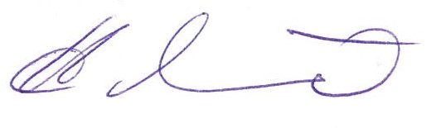 | Herbert Münder  Ecsite President  General Manager, Universum Bremen  Bremen, Germany

