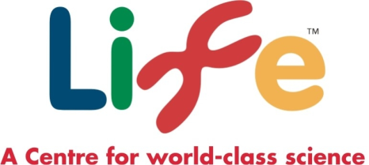
The International Centre for Life is a pioneering science village in the heart of Newcastle upon Tyne. It is an independent and self-funding charitable trust, which does not receive public funding.
Life’s mission is to ignite and nurture a curiosity in everyone for science, technology, engineering and maths and to encourage the next generation of STEM professionals. Life supports world-class science in the region and makes a positive economic, social and cultural contribution to North East England and its communities.
Life Science Centre, which opened in May 2000, is the only purpose-built Science Centre in the north, attracting over 250,000 visitors per year. Life’s varied and exciting Science engagement programme attracts a broad audience including families, adults, pre-schoolers and teenagers. Life also has the biggest schools’ science workshop programme in any European museum or Science Centre.

Science Engagement Director

We are looking to appoint a Science Engagement Director to be a key member of the executive management team. Reporting to the Chief Executive, your primary responsibilities will be to contribute actively to the overall mission, to manage a comprehensive Science engagement programme and to develop further Life’s international reputation for science engagement.

Science in the 21st century is fast moving, potentially life-enhancing and certainly controversial. As someone who is forward looking and an experienced science communications professional, you will excel in offering cutting edge science in a form that is easily accessible to everyone. You will be a strong leader, capable of developing a team that is both creative and effective. You will develop strategic alliances and partnerships with cultural and commercial organisations and build long term plans for exhibitions, programmes and education.

The successful candidate will have proven experience in a senior management role, will ideally have a post-graduate qualification in an appropriate science discipline, have excellent people management and organisational skills and be a team player.

This role offers potential for someone looking for a senior role with new challenges and wanting to work in an innovative place that is passionate about science. Salary is negotiable for the right candidate dependent on experience.

For an informal chat or more information about the role, please contact Linda Conlon, Chief Executive on 0191 243 8212 or email linda.conlon@life.org.uk. To see full job description and person specification please access at https://jobs.life.org.uk/ .

To apply, please send a letter of application and current CV to Claire Adams, Property and Corporate Services Director, International Centre for Life Trust, Management Suite, Times Square, Newcastle Upon Tyne, NE1 4EP or claire.adams@life.org.uk Closing date for applications is Friday, 24 November 2017.

Please note that the successful applicant will be subject to a DBS check. Details of our DBS policy are available on request.

The International Centre for Life is an equal opportunities employer and is accredited with the quality Standard Gold Award.

